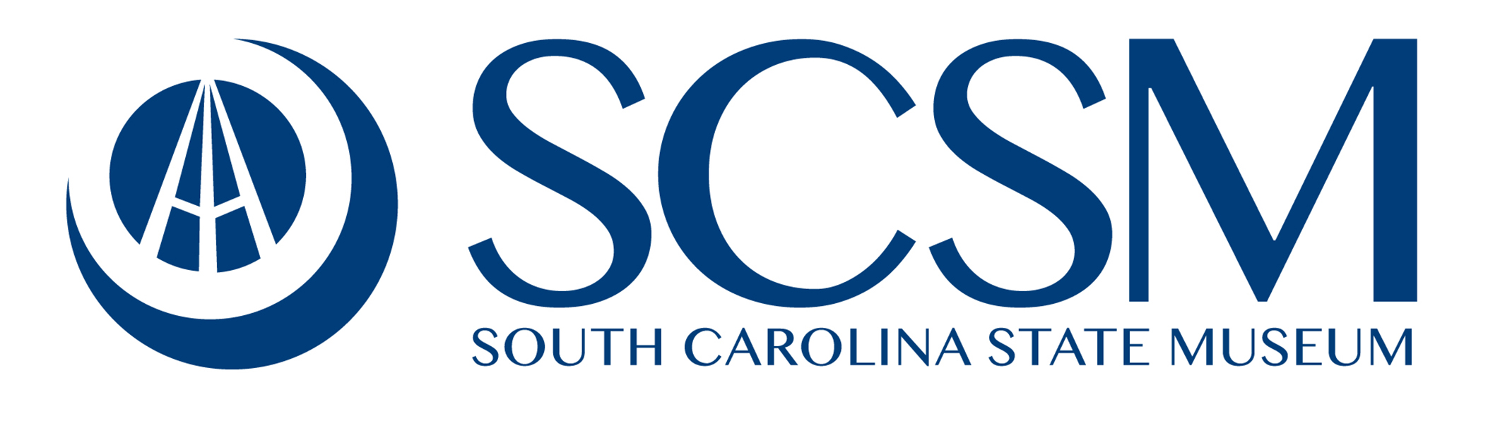
The State Museum collects, preserves, and presents the stories of South Carolina through engaging exhibits and programs that educate and enrich the visitor.
Our 30th Anniversary Year!!
Overview
The key current and long-term goal of the State Museum is to remain current, competitive, and unique in the market place while maintaining its educational point of difference. The State Museum is competing for discretionary dollars and leisure time with a multitude of other various attractions, events, and places.
State Museum’s AAM (American Alliance of Museums) Reaccreditation will be decided in February of 2019. Only 4% of museums nationwide are deemed worthy of Accreditation. State Museum has been accredited since 1992.
We have developed a 5 Year Strategic Plan as part of reaccreditation process. The plan addressed the key area of museum operations including – Public Service, Education, Collections Stewardship, Guest Services. Planning and Organizational Structure/Health
We additionally commissioned a Long-Term Visioning Project for not only the current footprint of the building but for all the surrounding properties. The plan is an articulation to the community of an overall identity of the District as a “cultural campus” with the State Museum as its heart.
2017.18 Recap
- Eclipse Highlights
  - Broke August’s attendance record with the positioning of “SCSM is the Eclipse Headquarters.”
  - Attendance of 8,300; Attributed revenues of $450,000; Incremental $205,000 in Retail Sales
- Total site attendance of 208,300; 64,000 school visits; all 46 counties!!
- $2,260,000 in earned revenues – third highest in 30 year history!
- Record year in Rental Income - $278,000
- Record year in store revenue - $837,700; $205,000 attributed to eclipse sales.
- Annual revenue of $97,200 for Winter, Spring Break, and Summer Camps representing 1814 campers
- Hospitality and Accommodations Tax Awards: City of Columbia: $48,000 Richland County: $47,629
- Marketing successfully branded the museum’s outreach programs, “Let’s Go L.E.A.R.N.”
- 29,079 students and teachers participated in over 993 formal in-house and outreach education classes.
- In-state outreach classes reached over 5300 students and teachers in 127 classes.
- 55,521 people attended planetarium astronomy, full dome and laser shows this year.
- 27,712 students, teachers, and chaperones attended planetarium shows.
- Education Department hosted a Spring Teacher Night and more than 60 teachers attended the event.
- Boeing Observatory distance learning reached 1200 students and teachers in 12 counties.
- Awarded IMLS grant of $209,000 to support the digitization and inventory of the Art Collection
- We distributed 19 travelling exhibitions across the state and to Texas and Virginia generating $6350.
- Secured $100,000 in naming rights of educational classrooms.
2019 Budget Request
- Recurring - $75,000
- Museum Artifact and Object Conservator - $60,000; 1 Appropriated Funded FTE
It is the responsibility of the museum to properly care for and maintain the objects that tell the stories related to our mission. The primary role of a conservator is to stabilize and manage long-term preservation of museum objects through examination, documentation, treatment, and preventative care. Due to the age and fragile condition of the 80,000 artifacts and nearly 200,000 natural history specimens in the museum’s diverse collection they require consistent monitoring and intervention to improve their long-term stability. By investing in specialized care for the collection, the State would actively preserve and protect our state’s treasures for future generations.
- PC Replacement - $15,000
Using the Dept of Admin's End-User Computing Devices Standard program to purchase new computers to replace 5+ year old aging hardware to guard against hardware failure and the limitations of the old hardware and allow the museum to provide a better guest experience.
- Grant Expenditure Authorization - $100,000
- Collections Art Inventory and Digitation Project- $100,000; 1 Grant Funded FTE
This grant request, submitted in December 2016, was for $209,223 to hire staff and purchase equipment to inventory the entire Art collection, improve basic storage conditions, create high-quality digital images and clean object records for each item in storage. At the end of the project, we hope to have 3,500 entries on our IMu portal, and an inventory process to use on the rest of the collection.

- Non-Recurring - $244,900
- Firewall Replacement - $30,000
Replace the current firewall with a next gen firewall and security appliance capable of integrated intrusion detection and prevention (IDS / IPS) to protect the agency network.

- Data Storage - $15,000
To increase onsite storage capabilities for data protection that is essential to thoroughly protect the agencies data, activities and assets.

- Ticketing EMV Chip and Pin - $15,000
To install credit card processing equipment that interfaces with our Point of Sale terminals to meet the new payment card industry EMV chip standard.

- Point of Sale Upgrade - $71,900
Replace aging hardware to guard against hardware failure and the limitations of the old hardware. This will also include new hardware to replace our Ticketing system and Membership database server.

- WIFI Expansion - $63,000
Expand the WIFI to include all public spaces in the museum to provide guests with a free and secure public WIFI option.

- Security Camera System - $50,000
Replace aging hardware to guard against hardware failure and allow the museum to provide better guest protection and the protection of museum assets and collection.
- Capital
Permanent Gallery Renovation - $15,000,000
State Funded = $10,000,000
Private funded = $ 5,000,000
Description of the request: The museum’s permanent exhibits are in need of renovation to better represent its expanding collection, replace outdated exhibit delivery systems and bring a 1980’s building infrastructure into the new millennium. More than half of the total museum collection remains in storage. Renovated galleries will allow for better representation of its rich history and the lessons we can learn from it and updated exhibit techniques will allow audiences to access information through a variety of mediums, ranging from dynamic displays to engaging interactives to innovative media presentations. Additional media also allows the museum to easily update content, whether in the form of touch screens, theaters or projection-mapped immersive environments. The building’s flooring and wall treatments are showing their age and an inefficient lighting system should be replaced with a more efficient and cost-effective LED system offering better conditions for artifact preservation. Creating a larger multi-use gallery on each floor will add the ability to present more content and provide additional income through increased rental opportunities. Finally, the galleries are in need of updated environmental graphics, signage and way-finding that complement the design language of the recent Windows to the World expansion.
Explanation of the request:
- South Carolina Museum Foundation would contribute $5,000,000 to the project bringing the total project cost to $15,000,000 Foundation sources would include private, foundation and corporate support
- This project begins phase two of the complete renovation of the museum. Phase 1 ($23.5 million) was opened in August of 2014 and included the addition of a planetarium, 4D theatre, observatory, telescope gallery and guest service and rental enhancements
- Phase 2 will transform the existing 3 floors of permanent exhibits to the same standard of quality as the WTNW components. No additional operating costs are needed. The construction would be phased so the museum would not close during the renovations as we would do one floor at a time.
Permanent Gallery Renovation
- The continued success of the South Carolina State Museum to preserve history, convey content, and engage guests remains dependent upon an ongoing commitment toward strategic and timely renovations of the museum’s facilities and exhibit program

- Over 30 years of constant use with no improvements has resulted in a facility that is well past its prime

- The galleries are in need of updated environmental graphics, signage, and way-finding that complement the design language of the recent Windows to the World expansion as well as better represent its expanding collection, replace outdated exhibit delivery systems, and bring the 1980s exhibits into the new millennium

- The exhibits are showing their age and an inefficient lighting system should be replaced with a more effective and cost-effective LED systems, offering better conditions for artifact preservation

- The collection is subject to negative environmental impacts including: fluctuations in temperature and humidity, water damage due to roof leaks, and insect damage due to deteriorating windows and doorways which allow easy access

- Today’s audiences expect to access information through a variety of mediums, ranging from dynamic displays to engaging interactives and innovative media presentations. Renovated galleries will allow for better representation of our rich history and the lessons we can learn from it

- The South Carolina State Museum Foundation would contribute $5,000,000 to the project, bringing the total project cost to $15,000,000

- The recent Windows to the New World expansion of SCSM’s public spaces dramatically improved the facility’s operations while simultaneously exposing its decidedly dated artifact displays, antiquated media techniques, and obsolete interactives—a situation over 30 years in the making

- This project would begin Phase 2 of the complete renovation of the museum (Phase 1 being the Windows to the New World project) transforming the existing 3 floors of permanent exhibits to the same standard of quality as the Windows to the New World components

- The Windows to the New Worlds renovation and expansion generated positive impressions of South Carolina by landing in USA Today (press = 6.9 million impressions). The Museum is now the only attraction in the nation to house a planetarium, 4D Theater, Observatory, and a multidisciplinary museum under one roof as well as our free public lobby featuring exhibits from three government or agency partners, Columbia Metropolitan CVB, South Carolina ETV, and the South Carolina PRT

- The Windows to the New Worlds renovation increased visitation, as well as traditional and social media exposure, web traffic, membership, cultural travel and tourism

